1. Install the below software from SOND. ( Raise a request to push it your profile if you don’t see in SOND )



1. Install Python Anaconda
2. Install Pycharm
3. After installations, Check whether you are able to access python from command prompt.

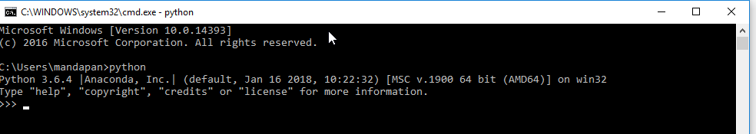

1. Accessing jupyter notebook and spyder

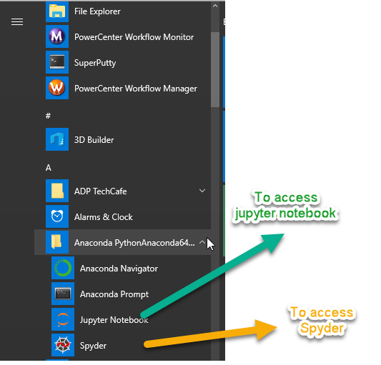

1. Open Pycharm IDE

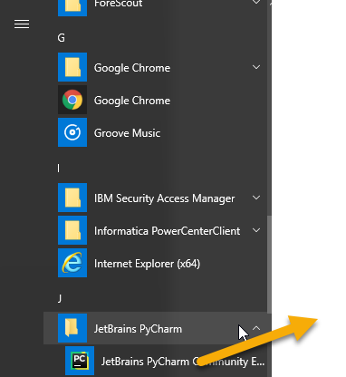

1. Setup pycharm project

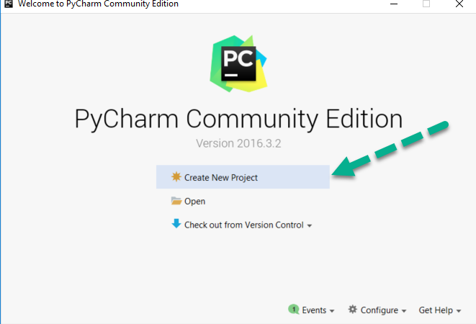

1. Create a project with <project name> at specified location

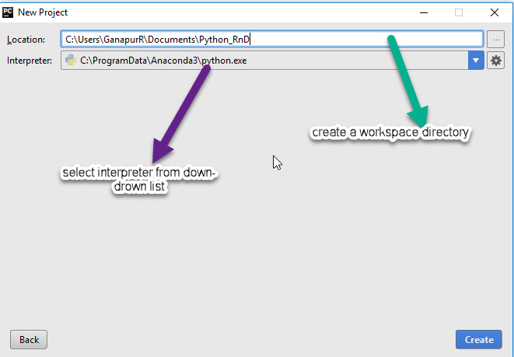

1. Navigate to the project in IDE and create python files.

